LAB NO# (05)

LAB TITTLE:
INSTALLATION OF ANACONDA FOR PYTHON
OBJECTIVE:
Introduction Of Python & How To Install Anaconda For Python /
How To Write A Simple Program
TOOLS:
- PC
- INTERNET
- BROWSER
- DOWNLOADER
INTODUCTION:
Python is a popular programming language. It was created by Guido van Rossum, and released in 1991.
It is used for:
- web development (server-side),
- software development,
- mathematics,
- system scripting
- Python can be used on a server to create web applications
- Python can be used alongside software to create workflows.
- Python can be used to handle big data and perform complex mathematics.
- Python can be used for rapid prototyping, or for production-ready software development.

PROCEDURES:

Download the Anaconda installer.
- Go to your Downloads folder and double-click the installer to launch. To prevent permission errors, do not launch the installer from the Favorites folder.
- Note
  - If you encounter issues during installation, temporarily disable your anti-virus software during install, then re-enable it after the installation concludes. If you installed for all users, uninstall Anaconda and re-install it for your user only.
- Click Next.
- Read the licensing terms and click I Agree.
- It is recommended that you install for Just Me, which will install Anaconda Distribution to just the current user account. Only select an install for All Users if you need to install for all users’ accounts on the computer (which requires Windows Administrator privileges).
- Click Next.
- Select a destination folder to install Anaconda and click Next. Install Anaconda to a directory path that does not contain spaces or unicode characters. For more information on destination folders, see the FAQ.
  - Caution
  - Do not install as Administrator unless admin privileges are required.
- 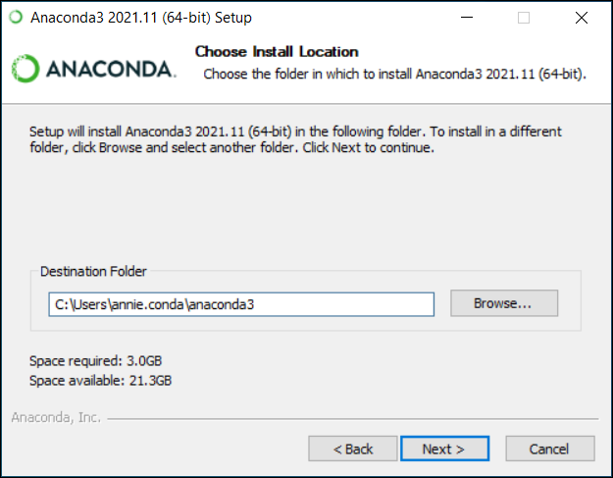

- Choose whether to add Anaconda to your PATH environment variable or register Anaconda as your default Python. We don’t recommend adding Anaconda to your PATH environment variable, since this can interfere with other software. Unless you plan on installing and running multiple versions of Anaconda or multiple versions of Python, accept the default and leave this box checked. Instead, use Anaconda software by opening Anaconda Navigator or the Anaconda Prompt from the Start Menu.
- Note
  - As of Anaconda Distribution 2022.05, the option to add Anaconda to the PATH environment variable during an All Users installation has been disabled. This was done to address a security exploit. You can still add Anaconda to the PATH environment variable during a Just Me installation.
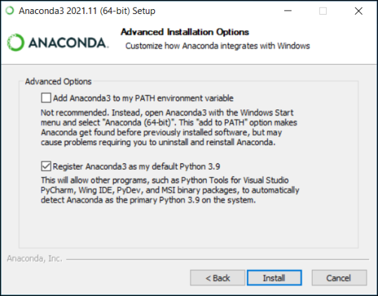
- Click Install. If you want to watch the packages Anaconda is installing, click Show Details.
- Click Next.
- Optional: To install Dataspell for Anaconda, click https://www.anaconda.com/dataspell.
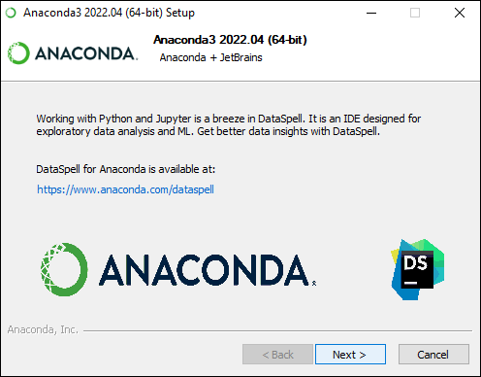

Or to continue without Dataspell, click Next.
- After a successful installation you will see the “Thanks for installing Anaconda” dialog box:
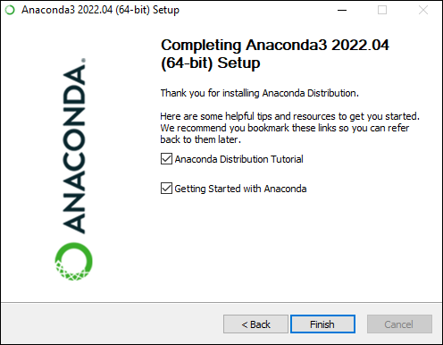
Click the Finish button.

WRITE SIMPLE PROGRAM
INPUT
#Addition of two number
A=5
B=6
S= A+B
Print (S)
input | output
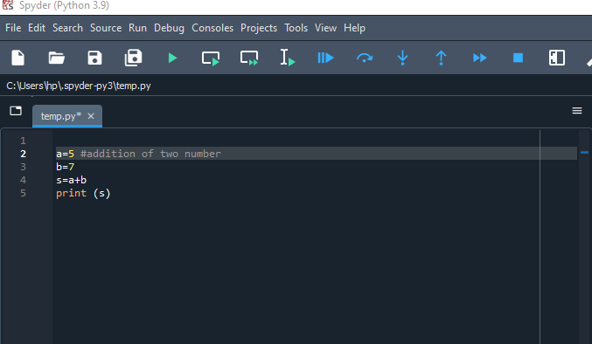 | 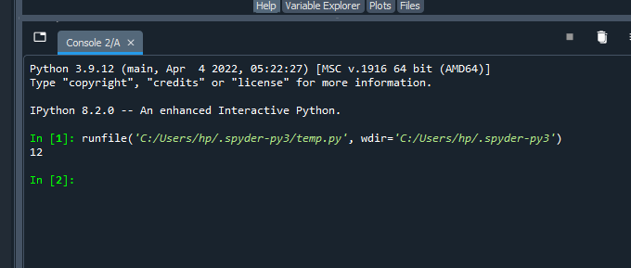

OBSERVATION
In this lab we observe or archived that how to install anaconda on pc for python language And how to write a simple program the addition and subtraction of two number in python

